IMG_256

### **[点微]同城分类信息**

同城分类信息平台

**阿里云OSS设置教程**

**第一步、开通阿里云OSS**

点击打开 [https://oss.console.aliyun.com/](https://oss.console.aliyun.com/" \t "http://www.tomwx.cn/_blank)

**第二步、创建 Bucket**

[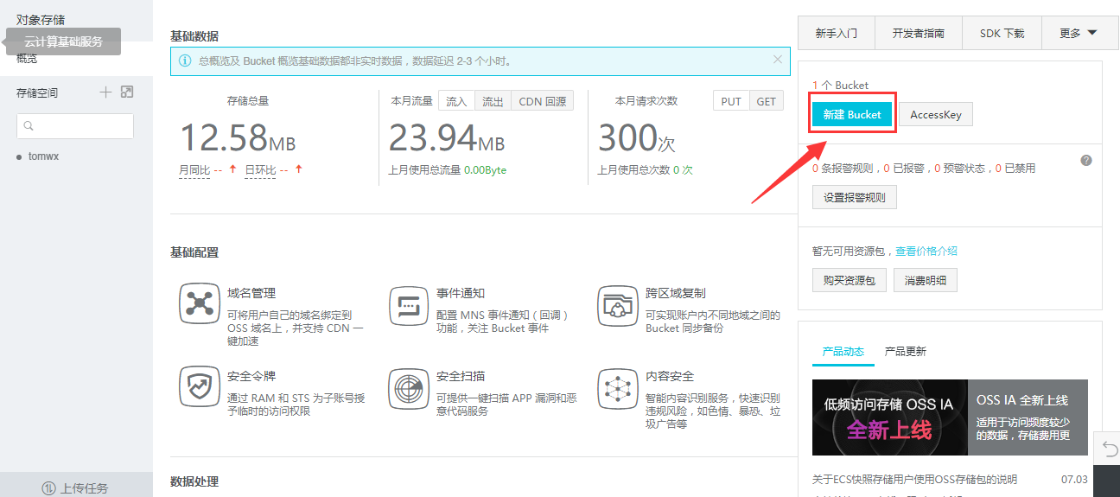](http://www.tomwx.cn/source/plugin/tom_editor/editor/attached/image/20170921/20170921115737_45926.png)

[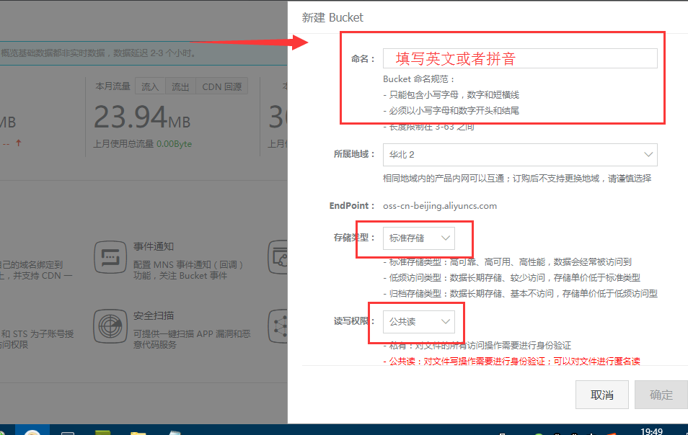](http://www.tomwx.cn/source/plugin/tom_editor/editor/attached/image/20170921/20170921115824_25582.png)

**第三步、获取 Bucket 和 EndPoint**

[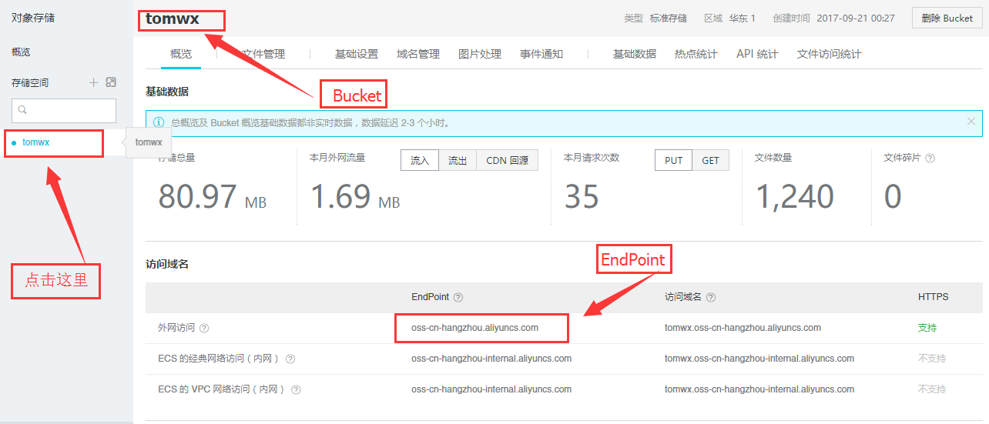](http://www.tomwx.cn/source/plugin/tom_editor/editor/attached/image/20171007/20171007103708_64731.png)

**第四步、获取  Access Key ID 和 Access Key Secret**

打开 [https://ak-console.aliyun.com/#/accesskey](https://ak-console.aliyun.com/" \l "/accesskey" \t "http://www.tomwx.cn/_blank)

[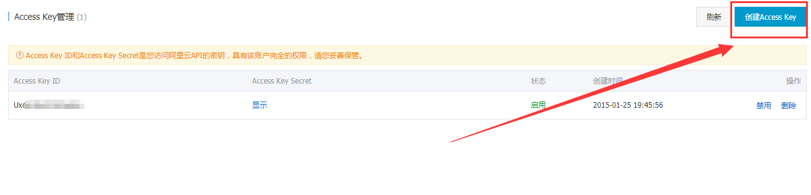](http://www.tomwx.cn/source/plugin/tom_editor/editor/attached/image/20170926/20170926064506_58160.png)

[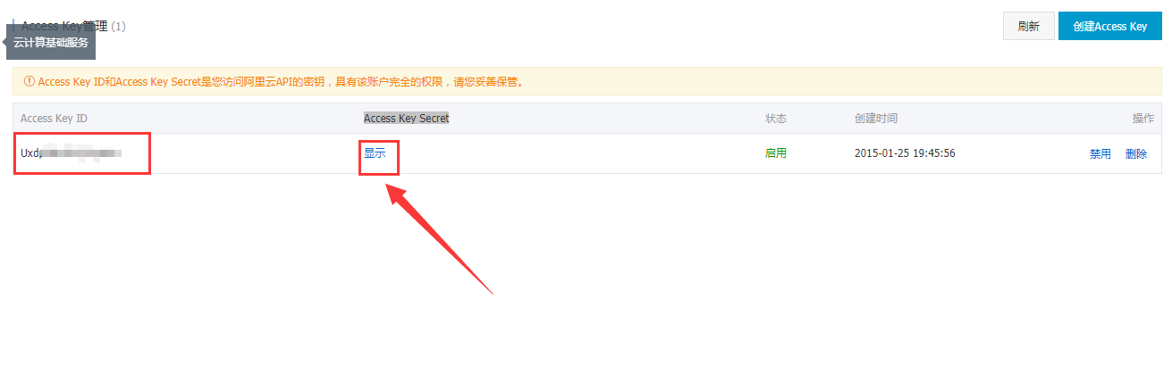](http://www.tomwx.cn/source/plugin/tom_editor/editor/attached/image/20170921/20170921115940_33359.png)

**第五步、后台设置**

[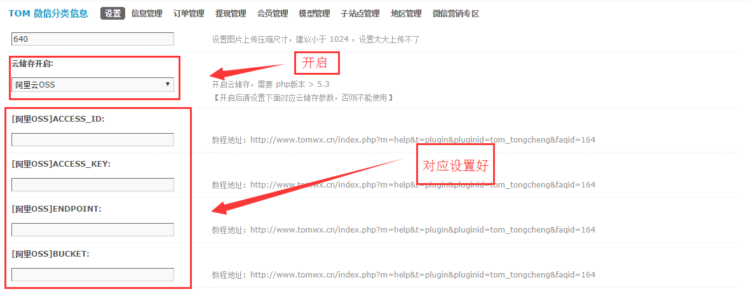](http://www.tomwx.cn/source/plugin/tom_editor/editor/attached/image/20170926/20170926065046_41195.png)

**第六步、手动执行同步之前的图片（点击一次程序会自动后台 执行，但是为了防止程序中断。请一个小时点一次，直到打开出现OVER 表示执行完毕）**

[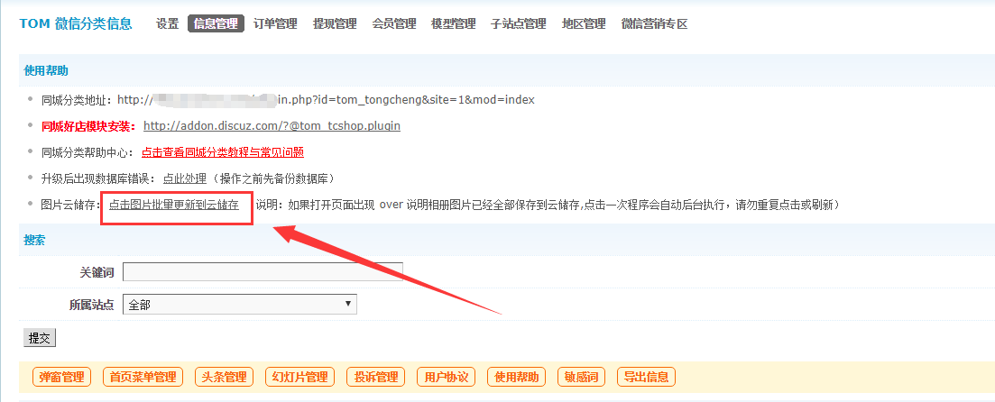](http://www.tomwx.cn/source/plugin/tom_editor/editor/attached/image/20170926/20170926065818_76963.png)